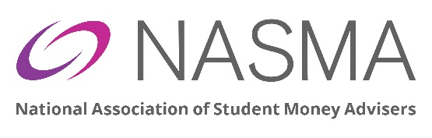
NASMA Member appointing proxy
Name | Job Title
Institution

Membership Category:
ORDINARY/ACCREDITED Yes/no HONORARY LIFE MEMBER Yes/no
(For office use only) Members voting status verified Yes/no
Proxy
I hereby authorise | Job Title
Institution:

To serve as my proxy and vote on my behalf at the NASMA AGM to be held on 8th June 2026. This proxy is valid for all matters voted on at the meeting.
Membership Category:
ORDINARY/ACCREDITED Yes/no HONORARY LIFE MEMBER Yes/no

(For office use only) Members voting status verified Yes/no

Form for NASMA member appointing a proxy for AGM 2026

Please return this form by email to office@nasma.org.uk

