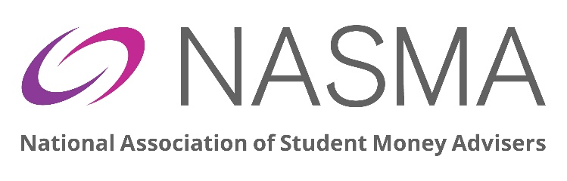

NASMA Annual General Meeting 2026
8th June 2026
Hybrid 11.15 – 12.15
AGENDA

1.Welcome and introduction by Kellie McAlonan, NASMA Chair
2.Minutes from the last Annual General Meeting (July 2025)
3.Accounts for year ending 31 August 2025
4.Reports from NASMA Board
5.Motions and Amendments to Motions – NONE
6.Nominations and Elections for Trustees/Directors
7.Honorary Life Membership
8.A0B – Questions from members

