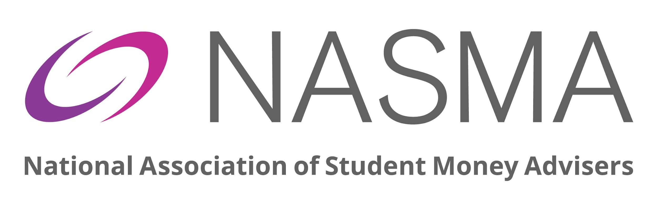

NASMA ANNUAL CONFERENCE 2026:

PROPOSAL FOR DELIVERING SESSION

Use this form to submit a session proposal for the NASMA Annual Conference 2026. The conference takes place on Monday 8th, Tuesday 9th and Wednesday 10th June 2026, at the Glasgow Marriott Hotel.

The conference theme will be Adapting, Advising, Acheiving and we are planning a vibrant and diverse schedule which will include information sessions, panel discussions, roundtables and networking opportunities.

You can use this form to make one session proposal. If you want to make more than one proposal, please submit a separate form for each. Please email your completed form to office@nasma.org.uk and we will be in touch.

Agreement
If your proposal is accepted, you agree to:
- Work with the NASMA Annual Conference team to develop and lead your session at the event.
- Provide copies of any presentation materials / resources at a date to be agreed with the NASMA team, to be shared with NASMA members.
- The inclusion of your name, job title and organisation on the delegate list, which is distributed to all attendees and sponsors.
- Allow use of your bio/photo and session details on NASMA communication channels, such as social media, member newsletters etc.
- Provide further information if required, possibly at reasonably short notice.

Your proposal

What’s the title of your session?

What’s your session about?
Please answer in 200 words or less.

Which kind of session is it?
Please choose one. If you want to submit more than one proposal, please submit a separate form for each.
☐ Workshop (involving practical input from delegates, enabling them to engage and interact with the topic)
☐ Presentation/Info Session (including time for questions and discussion)
If you selected workshop or presentation, how long will your session last?
☐ 30 minutes
☐ 60 minutes

What are the learning outcomes for attendees (workshop and presentation proposals only)?
What will participants take away from your session? Please answer in 150 words or less.

Will you be able to draw upon research an/or evaluated outcomes as part of your session?
We are particularly keen to showcase examples of evidence-based and evaluated practice that demonstrates a real impact. Please summarise these aspects of your session in 200 words or less.

Summarise the activities you will ask delegates to participate in (workshop proposals only)?
Please describe in 150 words or less and indicate the tool(s) / methods you intend to use, whether as part of physical or virtual delivery.

How many speakers will take part in your session?

On which days / times can you run your session?

Tick all that apply.

Only applicable if you can deliver at the physical conference. If you are offering to contribute virtually, we will contact you about this separately.
☐ Monday 8th June
☐ Tuesday 9th June
☐ Wednesday 10th June

Would you be prepared to run your session more than once during the conference?
Only applicable if you can deliver at the physical conference.
☐ Yes
☐ No

Any other comments about your session?
We can't always determine in advance how many will attend your session, but we will do our best to accommodate any minimum or maximum delegate numbers you feel might be appropriate, so make sure to tell us about this here.

Session leader contact details
Please provide the details of the person who will be your main contact for this proposal.

Title

First name

Last name

Job title

Organisation name

Email address

Phone number
Preferred pronouns  Please indicate the pronouns you want people to use to refer to you | ☐ She / her / hers  ☐ He / him / his  ☐ They / them / theirs

Any special requirements?
For example, access, sight / hearing, considerations for pregnant women etc.
Photography and filming  Photography and filming will take place throughout the event. We may use the photographs and video for marketing and publicity in our publications, on our website and on social media, or in any third-party publication. | ☐ I consent that NASMA can use photos or video of me in this way  ☐ I don’t want NASMA to use photos or video of me in this way

Co-presenter contact details
Please provide the details of any extra person who will co-present the session.
Title | Click or tap here to enter text.
First name | Click or tap here to enter text.
Last name | Click or tap here to enter text.
Job title | Click or tap here to enter text.
Organisation name | Click or tap here to enter text.
Email address | Click or tap here to enter text.
Phone number | Click or tap here to enter text.
Preferred pronouns  Please indicate the pronouns you want people to use to refer to you | ☐ She / her / hers  ☐ He / him / his  ☐ They / them / theirs
Any special requirements?  For example, access, sight / hearing, considerations for pregnant women etc. | Click or tap here to enter text.
Photography and filming  Photography and filming will take place throughout the event. We may use the photographs and video for marketing and publicity in our publications, on our website and on social media, or in any third-party publication. | ☐ I consent that NASMA can use photos or video of me in this way  ☐ I don’t want NASMA to use photos or video of me in this way

Extra session leaders
Please consider whether the number of co-presenters is appropriate for your session. For example, if your session is a 30 minute presentation, more than two presenters will limit the time each has to contribute.
If you want more people to take part in delivery of your session, please email NASMA at office@nasma.org.uk
Thank you for your proposal.
NASMA will contact you to confirm that we’ve received it.

