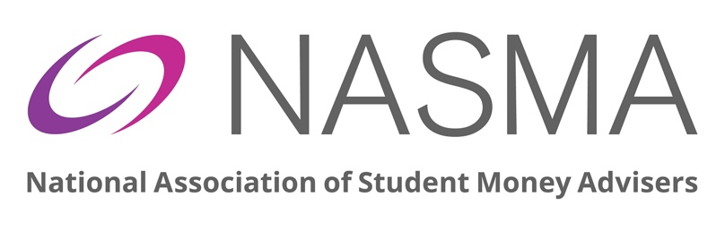

NASMA Money Advice Awards Nomination Form 2024

Before completing this nomination form, please read the information available online here, which includes details of each award, and FAQs that will help you understand how to progress a nomination.
Nominations should then be emailed to the NASMA Office (office@nasma.org.uk) by 00:00hrs on Monday 29th April 2024. Due to the complexities associated with managing the decision-making process, the deadline will be adhered to in all cases. You will receive an email acknowledgement within three working days to confirm we have received your application. If you do not receive an acknowledgement, please contact us urgently to confirm receipt.
The four NASMA Award categories are:
- Student Money Adviser of the Year
- Andrew Perry Memorial Award: Fund Administrator of the Year
- Team of the Year
- Innovative Project

TIPS FOR COMPLETING THIS FORM:
- There are 3 sections to this nomination form. All sections must be completed, taking care to ensure the accuracy of the information provided. If you are unsure how to complete any section of the nomination form, please contact us in advance of the deadline for assistance.

- This form must be submitted electronically via email, along with a written nomination, outlining how the nominee meets the award criteria and providing detail for the panel to consider when making their decision.

- This written nomination should be no less than 500 words and no more than 1000 words. It should be clear, concise and specific. You should provide as much detail as you can to allow the panel to understand why you feel the nominee should be selected as the winner. While data and outcome statistics are not required, this kind of detail can be helpful overall.

- You may include any supporting evidence you feel strengthens the nomination. This could be student feedback or testimonials, links to web resources, photographs of events etc. Any supporting evidence will be excluded from the word count noted above.

- It would be helpful to collate your submission into one PDF document, including this nomination form, the written nomination, and any supplementary evidence. We recommend a website called ilovepdf.com which will allow you to convert different file types to PDF format, and to then merge multiple PDF files into a single PDF document.

SECTION 1: ABOUT YOU, THE INDIVIDUAL MAKING THE NOMINATION:
Please provide your details:
Name
Email address
Contact number
Organisation
Job Title
Are you a NASMA Member? YES NO
Does the individual/service you are nominating know that they have been nominated? YES NO
Please confirm your relationship to the individual/service you are nominating for the award:

SECTION 2: ABOUT THE INDIVIDUAL/TEAM YOU ARE NOMINATING:
Please enter the details for the person(s) or team you wish to nominate.
In the case of a self-nomination, this may match section 1. If you do not know the NASMA Membership Number, leave this blank.
Name
University/College/SU Name:
-or-
Team Name
University/College/SU Name:
Please state the award category for which you are making this nomination:
(You can submit a nomination for more than 1 category but must use a separate form for each nomination)

SECTION 3: DECLARATION:
Name
Organisation
Date
I confirm that the information submitted as part of this application is correct. I understand that the decision of the Panel is final, and that no discussion will be entered into regarding the finalists or winners of the Awards.

